Handson 1

app.component.html

<h1>Hello World</h1>

<router-outlet></router-outlet>

Output

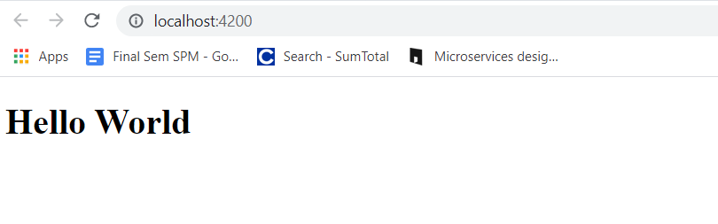

Handson -2

App.component.html

<h1>{{FavouriteMovie}}</h1>

<router-outlet></router-outlet>

app.component.ts

import { Component } from '@angular/core';

@Component({

selector: 'app-root',

templateUrl: './app.component.html',

styleUrls: ['./app.component.css']

})

export class AppComponent {

title = 'Angpro';

public FavouriteMovie:string = "Lord of the Rings";

}

Output

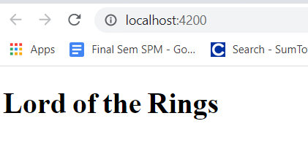

Handson-3-8

App.component.html

<h2>{{Titles}}</h2>

<strong>Id:</strong>{{Id}}<br>

<strong>Name:</strong>{{Name}}<br>

<strong>Salary:</strong>{{Salary}}

<br>

<span *ngIf="Permanent"><strong>Permanent</strong>Yes</span>

<br>

<strong>Department Id:</strong>{{Department_Id}}

<br>

<strong>Department Name:</strong>{{Department_Name}}

<br><br>

<strong>Skills</strong>

<br>

<span><strong>Skill Id Skill Name</strong></span>

<ol type="1">

<li *ngFor="let item of Skills">{{item}}</li>

</ol>

<strong>Date Of Birth: </strong>{{DateofBirth}}

<br>

<!-- Using pipe -->

<strong>Date Of Birth:</strong>{{DateofBirth | date}}

<br>

<router-outlet></router-outlet>

App.component.ts

import { Component } from '@angular/core';

@Component({

selector: 'app-root',

templateUrl: './app.component.html',

styleUrls: ['./app.component.css']

})

export class AppComponent {

title = 'Angpro';

//Handson 3

public Titles:string = "Employee Details";

  public Id:number=3;

  public Name:string="John";

  public Salary:number=10000;

//Handson 4

public Permanent:boolean=true;

//Handson 5

  public Department_Id:number=1;

  public Department_Name:string="payroll";

//Handson 6

  public Skills:string[]=["Html","Css","JavaScripts"];

//Handson 7

  public DateofBirth:Date=new Date('12/31/2000');

}

Output

